HIT140 FOUNDATIONS OF DATA SCIENCE
Predicting FIFA World Cup 2026 Match Outcomes with Linear Regression
Objective 2 – Model 2.1 (Goal Difference) and Model 2.2 (Team Goals)
1. Introduction
The report describes the analysis conducted through the linear regression to all 104 matches of FIFA World Cup 2026. In Objective 2 there are two related questions asked where the first model is 2.1 and second model is 2.2. In 2.1 the first model is about calculating the goal difference of a match from the perspective of the teams listed first in the official fixture. The second model 2.2 predicts how many goals are scored in a match by a team. Eight explanatory variables are used in each model, and the two models share nothing more than four fundamental ideas.
2. Data Preparation and Quality Control
The raw data have one row per match (104 rows, 29 columns). For every match both sides as labelled as team A and team B where the file records the final score after the casual time and any extra time; as they don't represent open-play scoring, goals from penalty shootouts are purposefully left out. There are 72 group matches, 16 Round of 32 matches, 8 Round of 16 matches, 4 quarterfinals, 2 semifinals, a third-place play-off, and the final match.
3. Feature Engineering
The identical raw file was used to create two datasets. Every variable in Dataset 2.1 is expressed as a difference between team A and team B, so a positive number always favors team A. Dataset 2.1 maintains one row each match. Dataset 2.2 creates 208 team-match rows by stacking every match twice, once from each team's point of view. FIFA ranking, Elo rating, host status, and rest days are the four common principles; the other factors are exclusive to each model.
Model 2.1 variable (A − B) | Meaning | Model 2.2 variable | Meaning
rank_diff * | FIFA rank gap (positive = A ranked higher) | fifa_rank * | Team’s FIFA rank
elo_diff * | Pre-match Elo rating gap | elo * | Team’s pre-match Elo
host_diff * | Host flag gap (−1, 0, 1) | host * | 1 if Mexico, South Africa or South Korea
rest_diff * | Gap in days since last match | rest_days * | Days since last match
wc_apps_diff | Gap in past World Cup appearances | attack_gf_pg | Goals scored per game, last 10
form_ppg_diff | Gap in points per game, last 10 | opp_defence_ga_pg | Opponent goals conceded per game
h2h_gd_pg | A’s historic goal difference vs B | opp_elo | Opponent’s pre-match Elo
elo_momentum_diff | Gap in 12-month Elo change | knockout | 1 if knockout-stage match
Table 1. Explanatory variables used in each model (* = shared concept).
4. Exploratory Data Analysis
The difference of the goal in Dataset 2.1 has mean of 0.50 and a standard deviation of 2.02, ranging from -4 to +6. The fixture list frequently names the stronger or home side first, which is consistent with the positive mean showing the first-listed team tended to perform significantly better. Its distribution is nearly symmetric (skew 0.29), making it a good fit for linear regression. The team goals in Dataset 2.2 exhibit distinct behaviour; they are small whole integers between 0 and 7 with a variance of 1.94, a mean of 1.48, and a distinct right skew of 1.15. A typical indicator of count data is a variance near the mean, which already suggests that a linear model could have trouble meeting the normalcy requirement for 2.2.
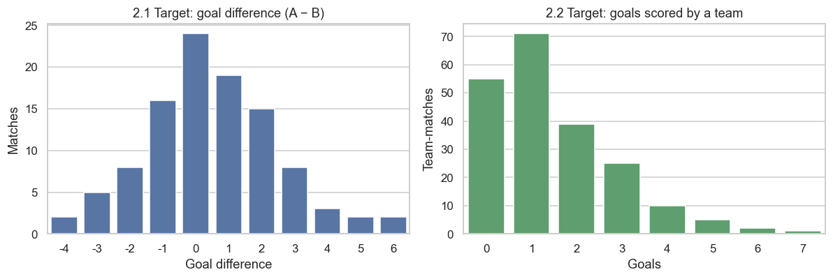
Figure 1. Distribution of the two target variables.
5. Methodology
Here models were analysed with an exact framework so that the results can be compared in a fair way:
- Multicollinearity: variance inflation factors (VIF) were computed, treating values above 5 as a warning and above 10 as serious.
- Inference: an ordinary least squares (OLS) model was fitted on the full data to obtain coefficients, p-values, confidence intervals, R² and adjusted R².
- Hold-out testing: an 80/20 train–test split measured R², RMSE and MAE on unseen data. A mean-only baseline, which always predicts the training average, served as the minimum standard a useful model must beat.
- Cross-validation: repeated 5-fold cross-validation (10 repeats) was used for 2.1. For 2.2, grouped by match ensured that both rows of the same match always fall in the same fold, preventing information about a match from leaking between training and testing.
- Assumption checks: residual-versus-fitted plots, Q–Q plots and histograms were examined, supported by the Breusch–Pagan test (constant variance), the Shapiro–Wilk test (normality) and the Durbin–Watson statistic (independence).
- Effect size: standardised coefficients were obtained by scaling every feature to unit variance, so that the influence of each variable can be compared on the same scale.

6. Results – Model 2.1: Goal Difference
The VIF values for rank_diff (7.28) and elo_diff (6.50) exceed the warning level, confirming the overlap noticed during exploration; all other variables are below 4. The full-data OLS fit is statistically significant overall (F = 9.47, p < 0.001) and explains 44.4% of the variation in goal difference (adjusted R² = 0.397). However, no single coefficient reaches significance at the 5% level. This is a classic symptom of correlated predictors: the variables jointly carry useful information, but the model cannot cleanly separate which one deserves the credit.
Variable | Coef. | p-value | Variable | Coef. | p-value
rank_diff | 0.0096 | 0.440 | wc_apps_diff | 0.0346 | 0.228
elo_diff | 0.0015 | 0.375 | form_ppg_diff | 0.6114 | 0.166
host_diff | 0.3834 | 0.397 | h2h_gd_pg | 0.1612 | 0.210
rest_diff | −0.0102 | 0.653 | elo_momentum_diff | 0.0007 | 0.781
Table 2. OLS coefficients for Model 2.1 (intercept 0.156, p = 0.379).
Turning predictions into results, the out-of-fold model picked the correct winner in 85.0% of the 80 decisive matches, which shows that even when the exact margin is hard to predict, the direction of the result is captured well. The residual diagnostics for Model 2.1 are satisfactory. The Breusch–Pagan p-value (0.268) gives no evidence of unequal variance, the Shapiro–Wilk p-value (0.075) does not reject normality at the 5% level, and the Durbin–Watson statistic (2.00) indicates independent errors.
7. Results – Model 2.2: Team Goals
Multicollinearity is concentrated in the team-strength pair, with VIF values with VIF values of 6.09 for elo and 5.65 for fifa_rank; all other features remain below 2. The overall model is significant (F = 9.08, p < 0.001) with R² = 0.267 and adjusted R² = 0.238. The lower R² compared with Model 2.1 is expected, because predicting the exact number of goals one team scores is harder than predicting the balance between two teams. Unlike Model 2.1, two variables are individually significant: the team’s recent attacking output (attack_gf_pg, p = 0.026) and the opponent’s Elo rating (opp_elo, p = 0.001).
Variable | Coef. | p-value | Variable | Coef. | p-value
fifa_rank | −0.0117 | 0.184 | attack_gf_pg | 0.3844 | 0.026
elo | 0.0005 | 0.714 | opp_defence_ga_pg | 0.2785 | 0.261
host | 0.4768 | 0.179 | opp_elo | −0.0023 | 0.001
rest_days | −0.0100 | 0.553 | knockout | −0.0566 | 0.800
Table 3. OLS coefficients for Model 2.2 (intercept 4.421, p = 0.123).
Statistically, a team's recent performance contributes roughly 0.38 predicted goals for every extra goal per game, while opponent Elo subtracts roughly 0.23 goals for every 100 points.
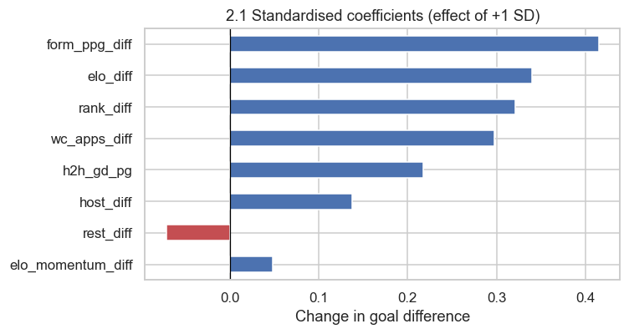 | 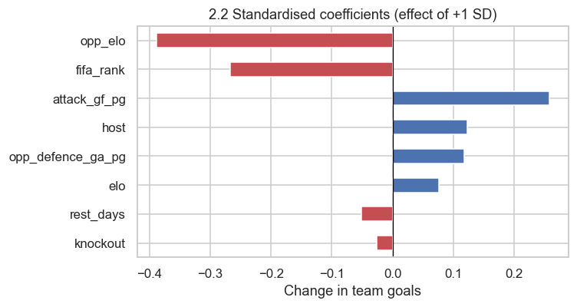
Figure 2. Standardised coefficients: Model 2.1 (left) and Model 2.2 (right).
Compared to Model 2.1, Model 2.2's predictive performance is more consistent. R2 was 0.233, RMSE was 1.228, and MAE was 1.030 on the match-grouped hold-out test, compared to a baseline RMSE of 1.402 and MAE of 1.187. In comparison to the baseline, which had a mean RMSE of 1.389, the grouped cross-validation yielded a mean R² of 0.157 with a tiny dispersion (standard deviation 0.064).
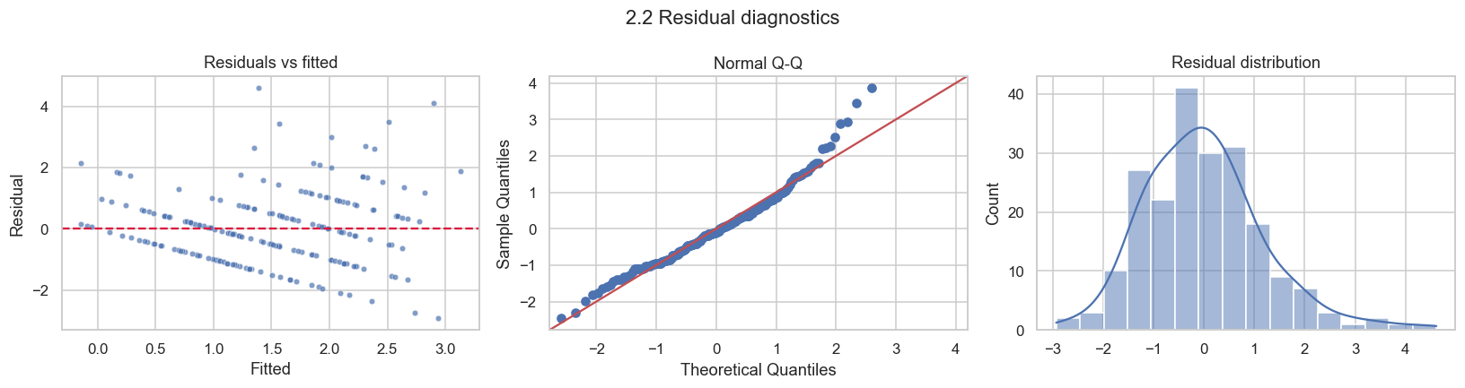 Figure 3. Residual diagnostics for Model 2.2.
When applied together, the two models demonstrate that pre-match data in tournament football has genuine but constrained predictive potential. Although Model 2.1 is excellent at determining the winner and accounts for a greater portion of the volatility, its precise goal-margin predictions are inconsistent across data splits. Goals are mostly determined by the strength of the opponent and the effectiveness of the team's recent offensive, according to Model 2.2, which explains less variation but generalizes more consistently.
Measure | Model 2.1 (goal difference) | Model 2.2 (team goals)
Rows / features | 104 / 8 | 208 / 8
R² / adjusted R² (full fit) | 0.444 / 0.397 | 0.267 / 0.238
Test R² / RMSE / MAE | 0.357 / 1.689 / 1.287 | 0.233 / 1.228 / 1.030
Baseline test RMSE / MAE | 2.108 / 1.741 | 1.402 / 1.187
CV mean R² (sd) | −0.160 (0.978) | 0.157 (0.064)
CV mean RMSE (model vs baseline) | 1.954 vs 2.013 | 1.254 vs 1.389
Significant features (p < 0.05) | None | attack_gf_pg, opp_elo
Assumptions (BP p / SW p / DW) | 0.268 / 0.075 / 2.00 | 0.032 / 0.0001 / 1.85
Table 4. Side-by-side summary of both models.
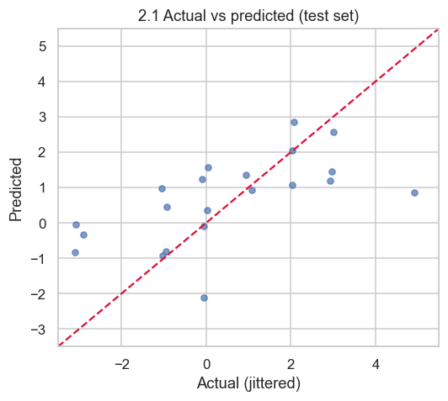 | 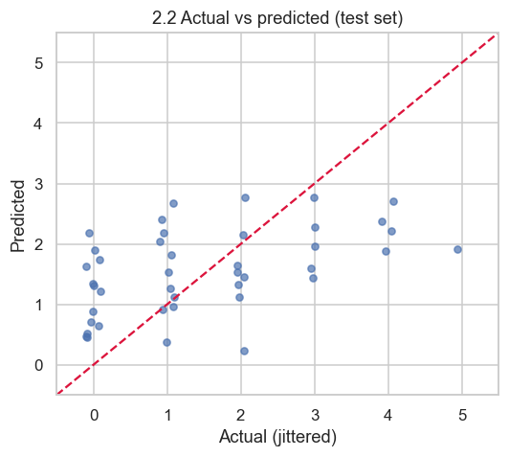
Figure 4. Actual versus predicted values on the test set: Model 2.1 (left) and Model 2.2 (right).

9. Limitations and Future Work
- Small sample: with 104 matches, a few unusual games can change the results noticeably, as the unstable cross-validation for Model 2.1 shows.
- Randomness of football: red cards, injuries, refereeing decisions and in-game tactics cannot be known before kick-off but strongly influence the score.
- Extra time: knockout matches that went to extra time had 30 additional minutes in which goals could be scored, which slightly inflates their totals.
- Model form: a Poisson or negative binomial regression would respect the count nature of team goals and is the natural next step, although the current brief requires linear regression. Regularised methods such as ridge regression could also reduce the instability caused by correlated features.

10. Conclusion
Both models demonstrate that pre-match strength, form, and opponent quality aid in predicting outcomes by outperforming a naive baseline on unobserved data. While Model 2.2 explains almost 27% of the variation in team goals and identifies attacking form and opponent Elo as important drivers, Model 2.1 explains roughly 44% of the variation in goal difference and chooses the winner in 85% of critical matches.

